Now we are going to talk about Hooks in react native.



You must have remembered in the last lesson of the series we discussed some Theoratical part of Lifecycle method and you must have thought that you will see some practical of Lifecycle method but you see hooks here. Why .It is because whenever you use lifecycle methods then you have to usen Hooks whether you talk about React native or React js especially in case of functional component So Teacher though that why not make a small lesson on it. It will be small lesson but not big lesson so that you have understood the idea of Hooks otherwise Teacher will say hooks in between life cycle and you will not understand anything

So we will study about Hooks so that lifecycle method will be easy for us. So now we understand its story that what it is and why we needed it. Initially when reactjs or React Native was formed then there was only class based component Now there was some problem with it that is Whoever were the beginners of js they were not comfortable with class based component reason being they did not know about object oriented programming and they have to write very big syntax in class based component and where we use normal javascript we write function there. So Facebook thought the why not make functional component and second thing was that the class component we made we had to write many code in it they had to make constructors , has to do rendering we did have to add inheritance we have to use this So to override all Facebook or Whoever made Reactjs or React native

So they thought that we will make everything in functional component So first think they did they introduces functional component but there was some limitation that inside functional component you can use state lifecycle method or context API you cannot use such things later come React 16.8

There they introduced new feature which was called Hooks. With the help of this you can do everything inside functional component that you could do in class based component .So the limitation of functional component are overrided . Now there is no limitation So now a definition will be shown what it says Now in official docs



The above is the url

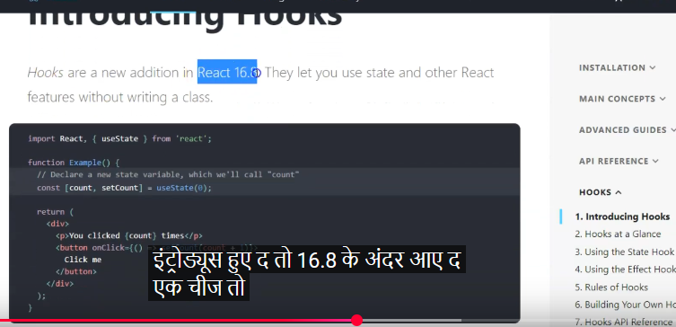

The hooks are nothing just an additional feature in react 16.8 . It is often asked when they were introduced . It is just a new feature which is nothing more Now what this do is that they let us use state and other React feature without writing a class

It means previously we could not achieve features in the functional component which we could do only in class component now you can use them inside the functional component with the help of hooks WE have used hooks previously whenever we have made state in the functional component then we have used Hooks



You can see in state definition syntax you can see useState it is a Hook.

3:25

If you want to see identify Hook in react native or react js wherever you see use Keyword then understand that is a Hook It is only used in functional component and cannot be used in class component This is also asked interview question

They could ask that the keyword which(maybe function) which start with use what are they called. We call them Hooks

Can you use Hooks in class based component. No you can use it only in functional component

So if they ask you what is Hook then you will answer that it is a new feature that was introduced in React 16.8 in which you can use state or lifecycle features in functional component

Now the question comes that will we never study about life cycle in class based component

See if we demand then teacher will tell us about it in a separate lesson

Nowadays nobody is using class based component

According to teacher on functional component 6-7 lesson will come on Hooks Teacher is talking about Hooks and lifecycle methods so it will be good there but still you need then teacher will make a separate lesson on life cycle

But mostly we will see with the functional component about lifecycle method and hooks and all.

Where and what we can use with hooks

Where you will make state in the functional component. You need to keep in mind that hook are only used in functional component SO with the help of hooks you can use state in functional component

You can use life cycle methods ,Context API ,Ref and Memo and much more and you can make even custom hooks How you can make it Teacher will tell us and What are ref and memo and How they are used What are context API How to use it, Teacher will tell us everything and from next lesson life cycle method series will start coming So interview question there will be lot that what are hooks and when they were introduced and can we use It in class based component No you cannot. Where you can use it we will see it.

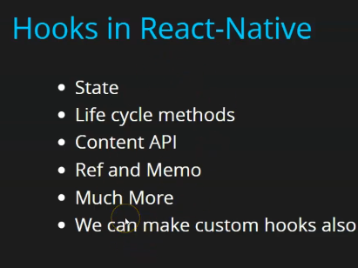

So that’s all for this lesson